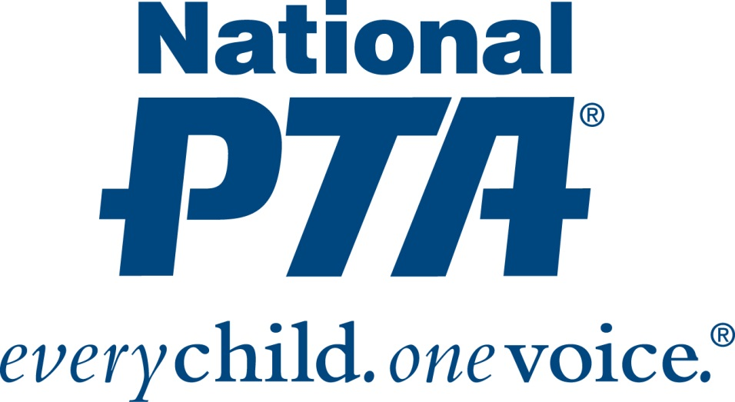

November is Healthy Lifestyles Month

Tips to Help Your Family Through Cold & Flu Season

Last year brought one of the worst cold and flu seasons in almost a decade, with children and older adults most impacted. Illness can affect more than just a child’s health - 38 million school days are lost each year due to the influenza virus.¹

Cold and flu season is back again, and as part of Healthy Lifestyles Month, the National PTA provides tips on recognizing differences between the two illnesses and how to help protect your family against the spread of cold and flu germs.

While both the cold and flu are respiratory illnesses characterized by similar symptoms, they are caused by different viruses, and the influenza virus is considered more severe. For this reason, it is recommended to seek advice from a doctor immediately upon developing flu-like symptoms.

Is it a Cold, or the Flu?²

It’s a Cold, if experiencing:
- Runny nose
- Sneezing
- Weepy eyes
- Nasal passage congestion
- Chills
- Body aches and fatigue
- Fever (uncommon in children over age 3)

It’s the Flu, if experiencing:
- Fever
- Body aches
- Extreme fatigue
- Dry cough

The single best way to help prevent catching the flu virus is to get vaccinated each season. In addition, taking extra care of your family is principal during the winter months. You can help ward off the cold and flu with simple preventative actions, such as limiting close contact with sick people and not touching your eyes, nose and mouth.³ Daily efforts can also be made at home and in the classroom to help ensure good health, such as increasing hand washing before and after eating, while handling pets and especially after caring for someone who is sick. Cleaning and disinfecting commonly-touched surfaces often will reduce the chance of spreading germs.

Cold and flu season shouldn’t be an afterthought, as it can quickly spread to the entire family once one member is infected. The best prevention is protection – and fortunately, there are things you can do to help yourself and family stay healthy.

¹ Centers for Disease Control and Prevention (CDC). Vital Health and Statistics. Current Estimates from the National Health Interview Survey, 1996. Available at http://www.cdc.gov/nchs/data/series/sr_10/sr10_200.pdf.
2 WebMD. Cold, Flu, & Cough Health Center. Available at: http://www.webmd.com/cold-and-flu/flu-guide/is-it-cold-flu.
3 Centers for Disease Control and Prevention (CDC). Everyday Preventive Actions That Can Help Fight Germs, Like Flu. Available at http://www.cdc.gov/flu/pdf/freeresources/updated/everyday_preventive.pdf.

# # #

